Super Group

# Team Members:

Andrew Magnus

Evan Clossen

Joseph Gates

# Project Title: Global Pin board

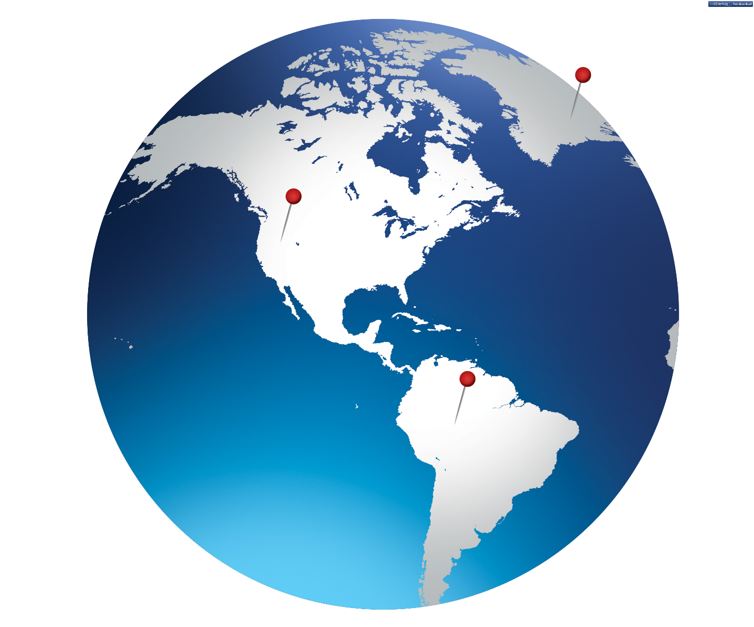

Project Summary

The idea of our project is to build a system in which people can create an online pin board of places they have traveled or want to travel to on an online account that can be shared or viewed by others. This way people can have a record /visual representation of their travels that they can view and update and share with others. (Login will be through Facebook or google+, so sharing will be done through that service). Pins will be color-coded with a standard set of colors or pin shapes, for example, places you have been could be colored according to whether you would return (or you think people should go there) to that place or not, so green for places you would go back to, and red for places you would not. Pins will also be accompanied with a name and a description. Pins will be able to be placed manually or through the location services of a device (you could press a button to get your current location and make a pin).

Users will be able to manage (delete/modify/add) pins within their map, pins will be attached to a persons account, so they are always available to be seen and updated.

Proposal

We propose to make a client-server application with a mobile responsive design. The tools we plan to use are HTML, PHP, JavaScript, MySQL and Bootstrap (including Jquery). Authentication will be done through Google+ and/or Facebook’s API (which uses OAuth)

